**Exercise 6: Configuring Beans with Annotations**

**Scenario:**

**You need to simplify the configuration of beans in the library management application using annotations.**

**Steps:**

**1. Enable Component Scanning:**

**o Update applicationContext.xml to include component scanning for the com.library package.**

**Ans.**

I have updated the applicationContext.xml

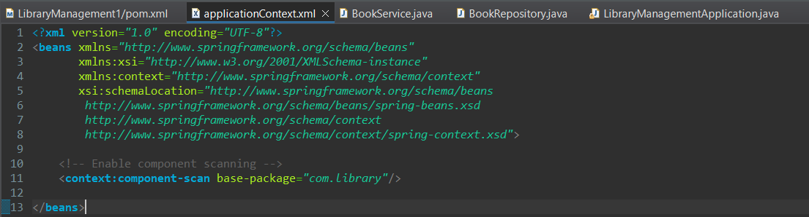

**2. Annotate Classes:**

**o Use @Service annotation for the BookService class.**

**Ans.**

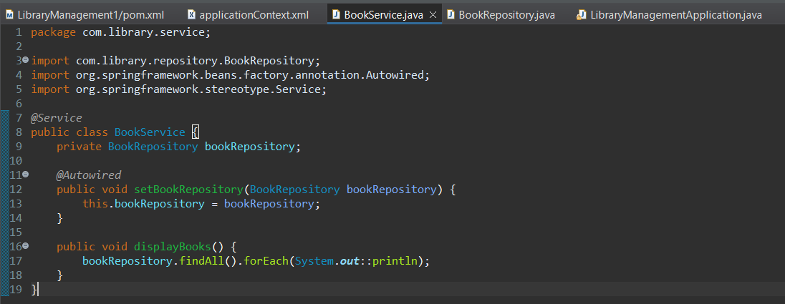

**o Use @Repository annotation for the BookRepository class.**

**Ans.**

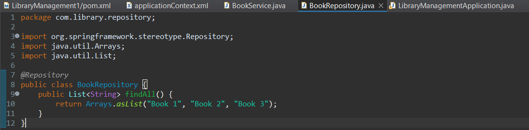

**3. Test the Configuration:**

**o Run the LibraryManagementApplication main class to verify the annotation-based configuration.**

**Ans.**

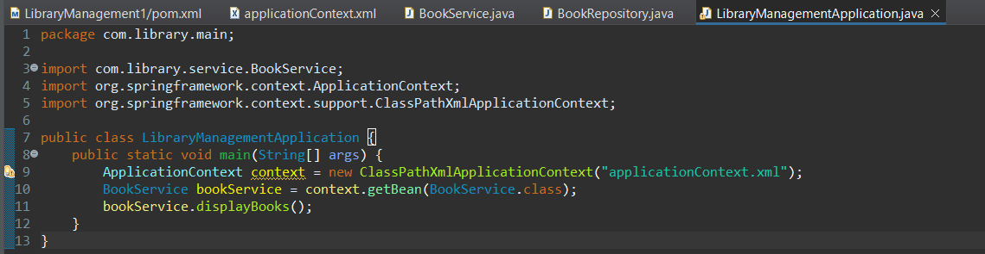

**Output: -**

